

# 

### Semester Two Examination, 2016

### Question/Answer Booklet

# MATHEMATICS

**SOLUTIONS**

**METHODS**

**UNITS 1 AND 2**

## Section Two:

## Calculator-assumed

|  |  |  |  |  |  |  |  |  |
| --- | --- | --- | --- | --- | --- | --- | --- | --- |
| Student Number: In figures |  |  |  |  |  |  |  |  |

In words

Your name

## Time allowed for this section

Reading time before commencing work: ten minutes

Working time for section: one hundred minutes

## Materials required/recommended for this section

***To be provided by the supervisor***

This Question/Answer Booklet

Formula Sheet (retained from Section One)

***To be provided by the candidate***

Standard items: pens (blue/black preferred), pencils (including coloured), sharpener, correction fluid/tape, eraser, ruler, highlighters

Special items: drawing instruments, templates, notes on two unfolded sheets of A4 paper, and up to three calculators approved for use in the WACE examinations

## Important note to candidates

No other items may be taken into the examination room. It is **your** responsibility to ensure that you do not have any unauthorised notes or other items of a non-personal nature in the examination room. If you have any unauthorised material with you, hand it to the supervisor **before** reading any further.

## Structure of this paper

|  |  |  |  |  |  |
| --- | --- | --- | --- | --- | --- |
| Section | Number of questions available | Number of questions to be answered | Working  time (minutes) | Marks available | Percentage of exam |
| Section One:  Calculator-free | 8 | 8 | 50 | 52 | 35 |
| Section Two:  Calculator-assumed | 12 | 12 | 100 | 98 | 65 |
|  | | | **Total** | 150 | 100 |

## Instructions to candidates

1. The rules for the conduct of examinations are detailed in the school handbook. Sitting this examination implies that you agree to abide by these rules.

2. Write your answers in this Question/Answer Booklet.

3. You must be careful to confine your response to the specific question asked and to follow any instructions that are specified to a particular question.

4. Spare pages are included at the end of this booklet. They can be used for planning your responses and/or as additional space if required to continue an answer.

* Planning: If you use the spare pages for planning, indicate this clearly at the top of the page.
* Continuing an answer: If you need to use the space to continue an answer, indicate in the original answer space where the answer is continued, i.e. give the page number. Fill in the number of the question that you are continuing to answer at the top of the page.

5. **Show** **all your working clearly**. Your working should be in sufficient detail to allow your answers to be checked readily and for marks to be awarded for reasoning. Incorrect answers given without supporting reasoning cannot be allocated any marks. For any question or part question worth more than two marks, valid working or justification is required to receive full marks. If you repeat any question, ensure that you cancel the answer you do not wish to have marked.

6. It is recommended that you **do not use pencil**, except in diagrams.

7. The Formula Sheet is **not** to be handed in with your Question/Booklet.

Section Two: Calculator-assumed 65% (98 Marks)

This section has**twelve (****12)** questions. Answer **all** questions. Write your answers in the spaces provided.

Working time for this section is 100 minutes.

Question 9 (6 marks)

(a) Determine the equation of the straight line that passes through the point $(8, 11)$ and is perpendicular to the line with equation $2x+5y=1$. (3 marks)

|  |
| --- |
| **Solution** |
| $$y=-\frac{2}{5}x+\frac{1}{5}$$ $$\text{Required gradient is }-1÷-\frac{2}{5}=\frac{5}{2}$$ $$y-11=\frac{5}{2}\left(x-8\right) \text{or} y=\frac{5}{2}x-9$$ |
| **Specific behaviours** |
| ✓ determines gradient of given line  ✓ determines required gradient  ✓ writes equation of line |

(b) Calculate and use the discriminant to determine the number of solutions to the equation $9x^{2}-24x+16=0$. (3 marks)

|  |
| --- |
| **Solution** |
| $$b^{2}-4ac={\left(-24\right)}^{2}-4×9×16 \\ =0 \\ \text{Hence one solution}$$ |
| **Specific behaviours** |
| ✓ substitutes into discriminant  ✓ evaluates  ✓ concludes one solution |

Question 10 (8 marks)

A walking club is planning a charity walk from Perth to Esperance. They plan to walk 20 km on the first day and 30 km every day after that. Food and camping supplies are to be set up at each overnight campsite in advance, using a vehicle based in Perth that is just large enough to carry enough for one campsite.

To leave the supplies at the first campsite, the vehicle must travel 40 km. For the second and third campsites, the vehicle must travel 100 km and 160 km respectively.

(a) Determine the distances the vehicle will travel to set up campsites four and five. (1 mark)

|  |
| --- |
| **Solution** |
| $$220 \text{km}, 280 \text{km}$$ |
| **Specific behaviours** |
| ✓ states both distances |

(b) Determine, in simplified form, a rule for the distance, $d$ km, that the vehicle will have to travel to set up campsite $n$. (2 marks)

|  |
| --- |
| **Solution** |
| $$d=40+\left(n-1\right)\left(60\right) \\ =60n-20$$ |
| **Specific behaviours** |
| ✓ uses AP general rule  ✓ simplifies |

(c) The vehicle can travel a maximum of 700 km on one tank of fuel. Determine the number of the furthest campsite the vehicle can leave supplies at, using no more than one tank of fuel. (2 marks)

|  |
| --- |
| **Solution** |
| $$60n-20=700 \\ n=12$$ The 12th campsite |
| **Specific behaviours** |
| ✓ writes equation  ✓ states number of campsite |

(d) If fuel costs 128 cents per litre and the fuel consumption of the vehicle is 9.5 litres per 100 km, determine the total fuel cost to set up the first 20 campsites. (3 marks)

|  |
| --- |
| **Solution** |
| $$S_{20}=\frac{20}{2}\left(2\left(40\right)+\left(19\right)\left(60\right)\right)=12200$$ $$12200÷100×9.5=1159 \text{litres} \\ 1159×1.28=\$1483.52$$ |
| **Specific behaviours** |
| ✓ calculates total distance  ✓ calculates number of litres  ✓ calculates cost, showing units |

Question 11 (8 marks)

Records show that of the 1756 washing machines sold by a retailer during 2015, 464 were deluxe models and the rest were standard. Of all the machines sold, 42 were returned and 31 of these returned machines were standard models.

(a) Determine how many of the standard models were not returned. (2 marks)

|  |
| --- |
| **Solution** |
| $$N_{S}=1756-464=1292$$ $$1292-31=1261$$ |
| **Specific behaviours** |
| ✓ calculates number of standard models  ✓ calculates number not returned |

(b) Calculate, to three decimal places, the probability that a randomly chosen machine from those sold

(i) was a standard model. (1 mark)

|  |
| --- |
| **Solution** |
| $$\frac{1292}{1756}=0.736$$ |
| **Specific behaviours** |
| ✓ calculates probability to 3dp |

(ii) was returned. (1 mark)

|  |
| --- |
| **Solution** |
| $$\frac{42}{1756}=0.024$$ |
| **Specific behaviours** |
| ✓ calculates probability to 3dp |

(iii) was returned given that it was a deluxe model. (2 marks)

|  |
| --- |
| **Solution** |
| $$\frac{42-31}{464}=\frac{11}{464}=0.024$$ |
| **Specific behaviours** |
| ✓ shows correct numerator and denominator  ✓ calculates probability to 3dp |

(c) Is there any indication that the likelihood of a machine being returned is independent of the model type? Explain your answer. (2 marks)

|  |
| --- |
| **Solution** |
| Yes.  Probability of being returned is the same for just deluxe models (0.024) and for all models (0.024) and so events are likely to be independent. |
| **Specific behaviours** |
| ✓ states YES  ✓ explains using calculated probabilities |

Question 12 (10 marks)

The graph of two functions and a circle of radius 3 units are shown.

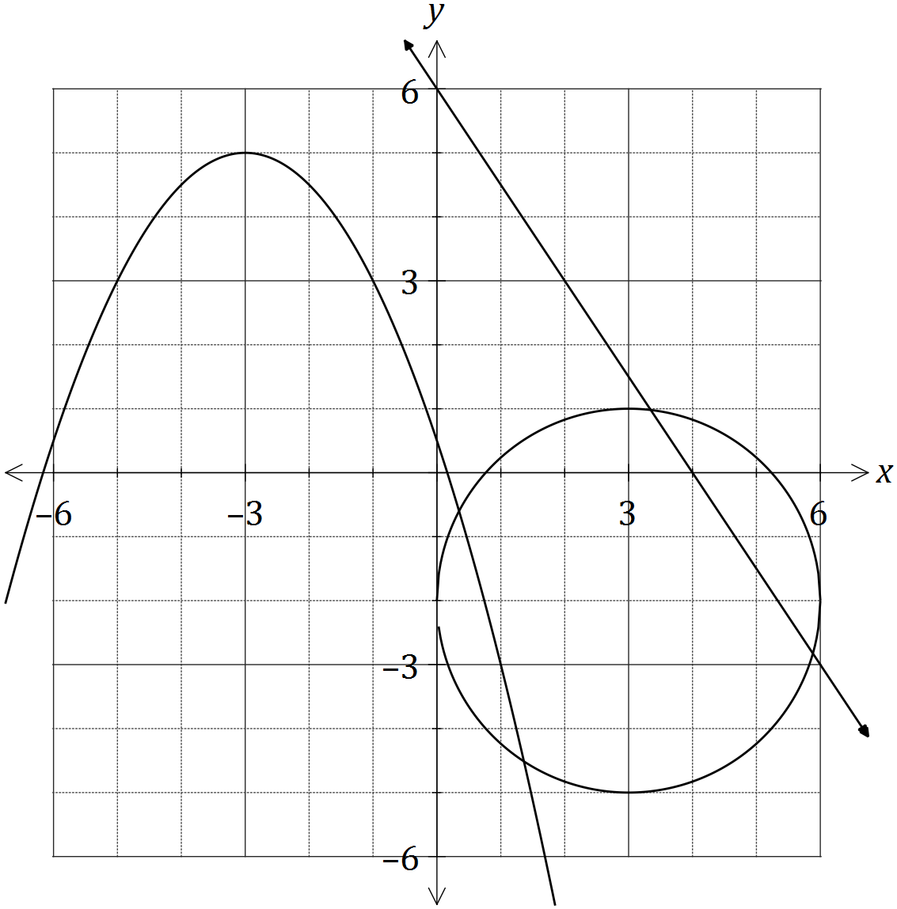

(a) One function is $f(x)=ax+b$. Determine the values of the constants $a$ and $b$. (2 marks)

|  |
| --- |
| **Solution** |
| $$a=-\frac{6}{4}=-\frac{3}{2} \\ b=6$$ |
| **Specific behaviours** |
| ✓ states value of  ✓ states value of $b$ |

(b) The relation can be written in the form $x^{2}+px+y^{2}+qy+r=0$.

Determine the values of the constants $p, q$ and $r$. (3 marks)

|  |
| --- |
| **Solution** |
| $$\text{Centre at} \left(3, -2\right)$$ $${\left(x-3\right)}^{2}+{\left(y+2\right)}^{2}=3^{2}$$ $$x^{2}-6x+y^{2}+4y+4=0$$ $$p=-6, q=4, r=4$$ |
| **Specific behaviours** |
| ✓ identifies centre of circle  ✓ writes in standard circle form  ✓ expands and states coefficients |

(c) The other function is $g\left(x\right)=cx^{2}+dx+e$.

(i) Determine the values of the constants $c, d$ and $e$, given that $g(x)$ has a maximum at $(-3, 5)$. (3 marks)

|  |
| --- |
| **Solution** |
| $$g\left(x\right)=c{\left(x+3\right)}^{2}+5$$ $$g\left(-1\right)=3⇒c\left(4\right)+5=3⇒c=-\frac{1}{2}$$ $$g\left(x\right)=-\frac{1}{2}{\left(x+3\right)}^{2}+5=-\frac{1}{2}x^{2}-3x+\frac{1}{2}$$ $$c=-\frac{1}{2}, d=-3, e=\frac{1}{2}$$ |
| **Specific behaviours** |
| ✓ uses turning point form  ✓ determines  ✓ expands and states other coefficients |

(ii) State coordinates of the turning point of the graph of $y=g(x-7)$. (1 mark)

|  |
| --- |
| **Solution** |
| $$\text{Translates 7 units right}: \left(4, 5\right)$$ |
| **Specific behaviours** |
| ✓ states coordinates of TP |

(iii) State the range of the function $y=-g(x)$. (1 mark)

|  |
| --- |
| **Solution** |
| $$\text{Reflects in x-axis}:\left\{y:y∈R, y≥-5\right\}$$ |
| **Specific behaviours** |
| ✓ states range |

Question 13 (7 marks)

In triangle $PQR$, $PR=50$ cm, $QR=30$ cm and $∠QPR=25°$.

(a) Show that $∠PQR$ can be $44.8°$ or $135.2°$. (3 marks)

|  |
| --- |
| **Solution** |
| $$\frac{50}{\sin{Q}}=\frac{30}{\sin{25}}$$ $$∠Q=44.8 \text{or} 180-44.8=135.2$$ $$∠Q=44.8⇒∠R=110.2 \text{and} ∠Q=135.2⇒∠R=19.8$$ |
| **Specific behaviours** |
| ✓ substitutes into sine rule  ✓ shows values are supplementary solutions  ✓ shows that both triangles exist by checking $∠R$ |

(b) Showing use of trigonometry, determine

(i) the largest possible length of $PQ$. (2 marks)

|  |
| --- |
| **Solution** |
| $$\frac{PQ}{\sin{110.2}}=\frac{30}{\sin{25}} \\ PQ=66.6 \text{cm}$$ |
| **Specific behaviours** |
| ✓ shows use of largest value of $∠R$ in sine or cosine rules  ✓ calculates length |

(ii) the smallest possible area of triangle $PQR$. (2 marks)

|  |
| --- |
| **Solution** |
| $$A=\frac{1}{2}×50×30×\sin{19.8} \\ A=254 {\text{cm}}^{2}$$ |
| **Specific behaviours** |
| ✓ shows use of smallest value of $∠R$ in area formula  ✓ calculates area |

Question 14 (9 marks)

The function $f$ is given by $f\left(x\right)=x^{3}-3x+2$.

(a) Show that the graph of $y=f(x)$ has two roots and state their coordinates. (2 marks)

|  |
| --- |
| **Solution** |
| $$x^{3}-3x+2=\left(x+2\right){\left(x-1\right)}^{2}$$ $$\left(x+2\right){\left(x-1\right)}^{2}=0⇒x=-2, 1$$ $$\text{Two roots at} \left(-2, 0\right) \text{and} (1, 0)$$ |
| **Specific behaviours** |
| ✓ factorises  ✓ states coordinates of roots |

(b) Use calculus techniques to determine the coordinates of all stationary points of the graph of $y=f(x)$. (4 marks)

|  |
| --- |
| **Solution** |
| $$f^{'}\left(x\right)=3x^{2}-3$$ $$3\left(x-1\right)\left(x+1\right)=0⇒x=-1, 1$$ $$\text{At} \left(-1, 4\right)\text{and} (1, 0)$$ |
| **Specific behaviours** |
| ✓ differentiates  ✓ shows that  ✓ solves  ✓ states coordinates |

(c) Sketch the graph of $y=f(x)$ on the axes below for $-2≤x≤2$. (3 marks)

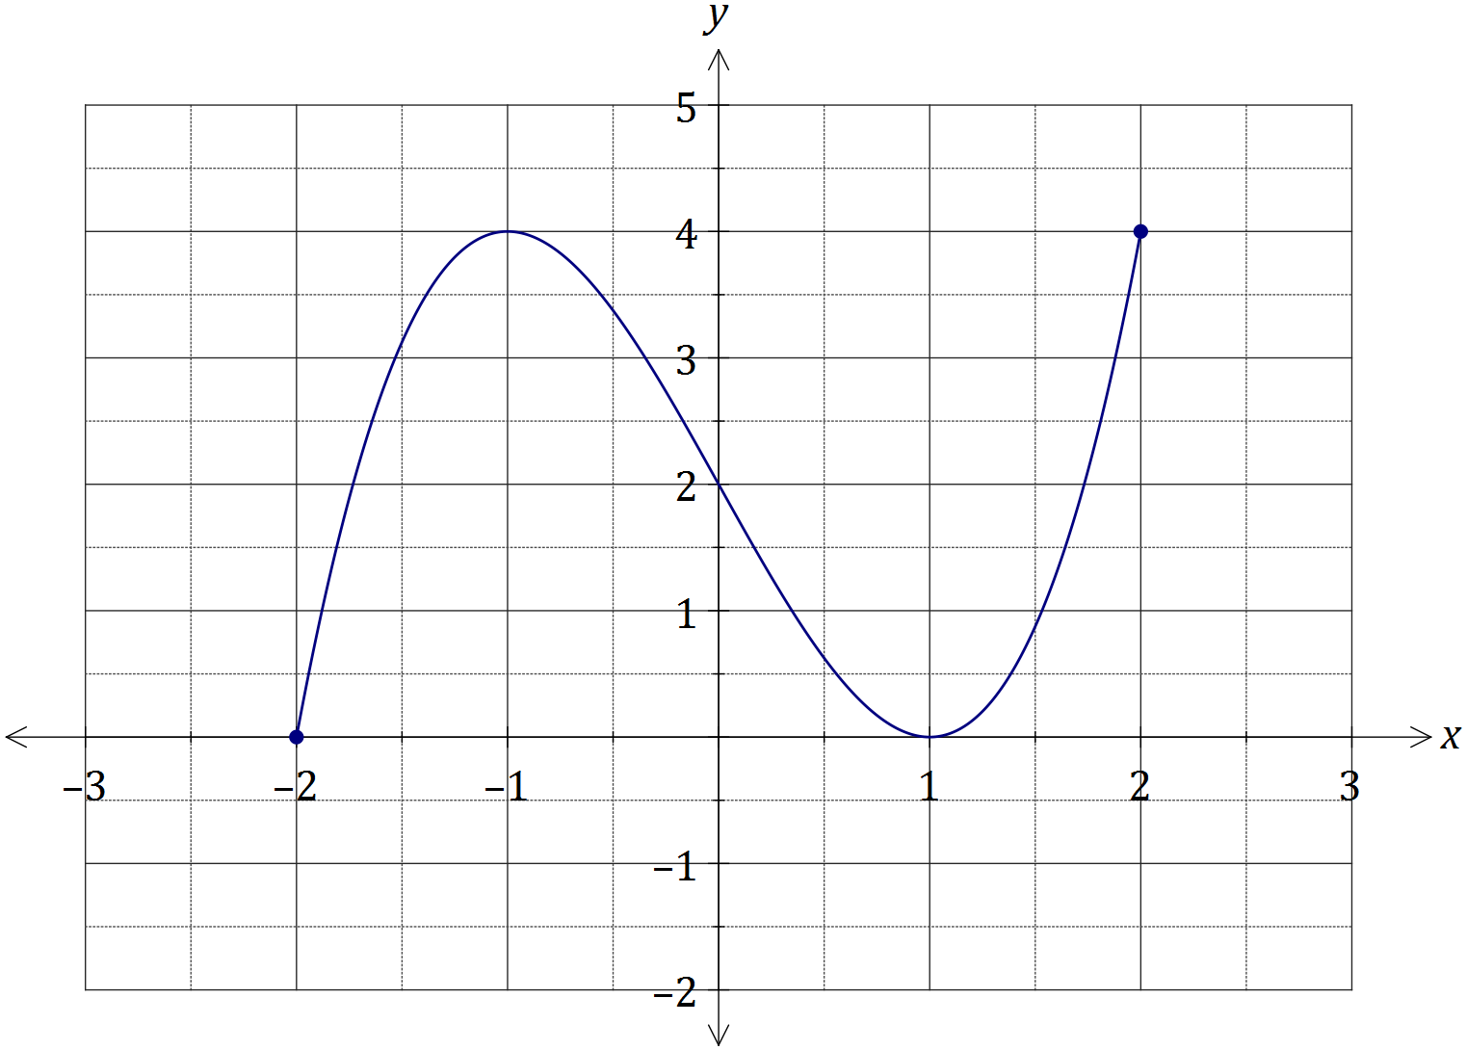

|  |
| --- |
| **Solution** |
| See graph |
| **Specific behaviours** |
| ✓ stationary points  ✓ roots and $y$-intercept  ✓ smooth curve within given domain |

Question 15 (10 marks)

(a) The graphs of $f(x)=a\sin{(bx)}$ and $g(x)=c\cos{(x+d)}$, where $x$ is in degrees, are shown below.

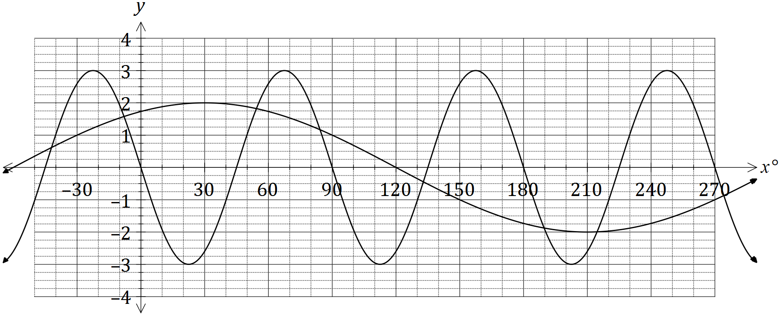

(i) Determine the values of the constants $a, b, c$ and $d$. (4 marks)

|  |
| --- |
| **Solution** |
| $$a=-3, b=\frac{360}{9}=4, c=2, d=-30$$ |
| **Specific behaviours** |
| ✓✓✓✓ each value |

(ii) Use the graph to solve $f\left(x\right)=g\left(x\right), 0°≤x≤180°$. (2 marks)

|  |
| --- |
| **Solution** |
| $$x=54°, 84°, 133°$$ |
| **Specific behaviours** |
| ✓ three solutions, two within  ✓ all solutions within $±1°$ |

(b) $P$ and $Q$ are acute angles with $\sin{P}=\frac{12}{13}$ and $\cos{Q}=\frac{15}{17}$. Determine the **exact** value of $\cos{(P-Q)}$. (4 marks)

|  |
| --- |
| **Solution** |
| $P$ is a 5-12-13 triangle and $Q$ is a 8-15-17 triangle  Hence $\cos{P}=\frac{5}{13}$ and $\sin{Q}=\frac{8}{17}$ $$\cos\left(P-Q\right)=\cos{P}\cos{Q}+\sin{P}\sin{Q}=\frac{5}{13}∙\frac{15}{17}+\frac{12}{13}∙\frac{8}{17}=\frac{171}{221}$$ |
| **Specific behaviours** |
| ✓ obtains exact values for  ✓ obtains exact values for  ✓ substitutes into double angle formula  ✓ evaluates correctly  *NB ✓ only for 0.7737556561* |

Question 16 (8 marks)

The imprisonment rate $R$, in number of prisoners per 100 000 people, in the US between the years 1960 and 2000, can be modelled by the following equation, where $n$ is the year.

$$R=85{\left(1.038\right)}^{n-1960}$$

|  |
| --- |
| **Solution** |
| $$R=378$$ |
| **Specific behaviours** |
| ✓ calculates rate |

(a) Calculate the imprisonment rate in the year 2000. (1 mark)

(b) Draw the graph of the imprisonment rate for 1960 $≤n≤$ 2000 on the axes below.

(3 marks)

|  |
| --- |
| **Solution** |
| See graph |
| **Specific behaviours** |
| ✓ starts at (1960, 85)  ✓ passes through (2000, 378) & (1980, 179)  ✓ smooth continuous curve |

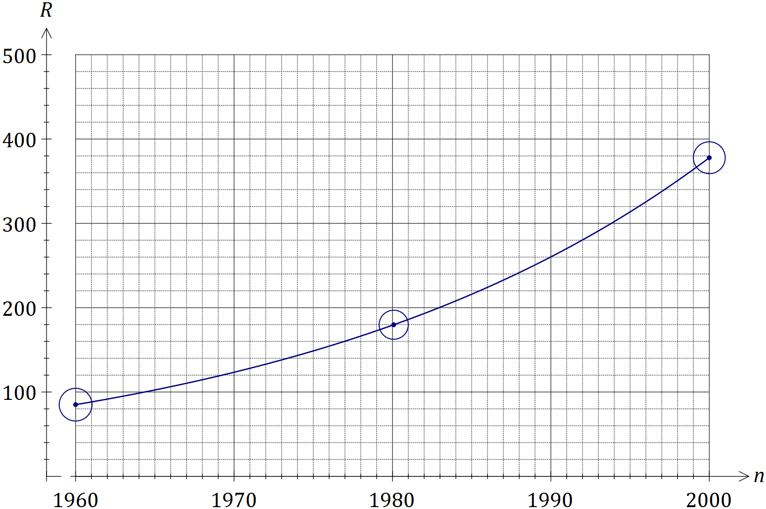

(c) The population of the US was 266 million in 1995. Determine the number of prisoners in the US at this time, to the nearest 1 000. (3 marks)

|  |
| --- |
| **Solution** |
| $$R\left(1995\right)=313.564$$ $$313.564÷100000×266000000=834080$$ $$834 000 \text{prisoners}$$ |
| **Specific behaviours** |
| ✓ calculates rate, maintaining accuracy  ✓ adjusts for population  ✓ rounds at end as required |

(d) When $R$ first exceeded 500, steps were taken to address the exponential growth in the prison population and the model no longer applied. In what year did this occur? (1 mark)

|  |
| --- |
| **Solution** |
| $$500=85{\left(1.038\right)}^{n-1960}⇒n=2007.5⇒\text{During }2007$$ |
| **Specific behaviours** |
| ✓ solves for $n$ |

Question 17 (8 marks)

The perimeter of a sector of a circle, of radius $r$ cm and central angle $θ$ radians, is 60 cm.

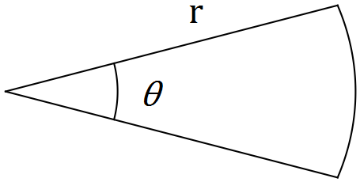

(a) Show that $θ=\frac{60}{r}-2$. (2 marks)

|  |
| --- |
| **Solution** |
| Perimeter of sector is given by $P=2r+rθ$ Hence $60=r\left(2+θ\right)⇒θ=\frac{60}{r}-2$ |
| **Specific behaviours** |
| ✓ expression for perimeter  ✓ substitutes and re-arranges |

(b) Show that the area of the sector is given by $30r-r^{2}$. (2 marks)

|  |
| --- |
| **Solution** |
| $$A=\frac{1}{2}r^{2}θ$$ $$=\frac{1}{2}r^{2}\left(\frac{60}{r}-2\right)$$ $$=30r-r^{2}$$ |
| **Specific behaviours** |
| ✓ substitutes $θ$ from (a) into area formula  ✓ simplifies |

(c) Use calculus to determine the maximum area of the sector and state the values of $r$ and $θ$ that achieve this maximum. (4 marks)

|  |
| --- |
| **Solution** |
| $$\frac{dA}{dr}=30-2r$$ $$30-2r=0⇒r=15$$ $$A=30\left(15\right)-{15}^{2}=225 {\text{cm}}^{2}$$ $$θ=\frac{60}{15}-2=2 \text{radians}$$ |
| **Specific behaviours** |
| ✓ differentiates  ✓ solves derivative to zero, stating  ✓ calculates area  ✓ calculates $θ$ |

Question 18 (8 marks)

(a) Two students are to be chosen from a class of 18.

(i) Determine how many different pairs of students may be chosen. (1 mark)

|  |
| --- |
| **Solution** |
| $$\left(\begin{matrix}18 \\ 2\end{matrix}\right)=153$$ |
| **Specific behaviours** |
| ✓ calculates combinations |

(ii) One of the students in the class is the oldest in the school. What is the probability that this student is included in the pair chosen? (2 marks)

|  |
| --- |
| **Solution** |
| $$\left(\begin{matrix}1 \\ 1\end{matrix}\right)×\left(\begin{matrix}17 \\ 1\end{matrix}\right)=17$$ $$\frac{17}{153}=\frac{1}{9}$$ |
| **Specific behaviours** |
| ✓ calculates ways to choose oldest  ✓ calculates probability |

(b) A box contains 13 cans of soup, four of which have tomato as an ingredient and the remainder that do not. Four cans are to be selected at random from the box.

(i) Calculate how many different selections of four cans can be made from the box.

(1 mark)

|  |
| --- |
| **Solution** |
| $$\left(\begin{matrix}13 \\ 4\end{matrix}\right)=715$$ |
| **Specific behaviours** |
| ✓ calculates combinations |

(ii) Determine the probability that none of the four cans will have tomato as an ingredient.

(2 marks)

|  |
| --- |
| **Solution** |
| $$\left(\begin{matrix}9 \\ 4\end{matrix}\right)=126;\frac{126}{715}=0.176$$ |
| **Specific behaviours** |
| ✓ chooses four from the 9 non-tomato  ✓ calculates probability |

(iii) Determine the probability that in the selection of four cans, there will be an equal number of cans with and without tomato as an ingredient. (2 marks)

|  |
| --- |
| **Solution** |
| $$\left(\begin{matrix}4 \\ 2\end{matrix}\right)\left(\begin{matrix}9 \\ 2\end{matrix}\right)=6×36=216;\frac{216}{715}=0.302$$ |
| **Specific behaviours** |
| ✓ chooses 2 tomato and 2 non-tomato  ✓ calculates probability |

Question 19 (7 marks)

(a) A sequence is defined by $T_{n+1}=T_{n}-7, T_{1}=111$.

(i) Determine $T_{20}$. (1 mark)

|  |
| --- |
| **Solution** |
| $$111+\left(19\right)\left(-7\right)=-22$$ |
| **Specific behaviours** |
| ✓ calculates term |

(ii) The sum of the first 40 terms, $S_{40}$. (1 mark)

|  |
| --- |
| **Solution** |
| $$\frac{40}{2}\left(2\left(111\right)+\left(39\right)\left(-7\right)\right)=-1020$$ |
| **Specific behaviours** |
| ✓ calculates sum |

(iii) The value of $n$ that maximises $S_{n}$. (2 marks)

|  |
| --- |
| **Solution** |
| By inspection of table of values, $S_{15}=930, S_{16}=936 \text{and} S_{17}=935$.  Hence maximum value is $936$ when $n=16$. |
| **Specific behaviours** |
| ✓ identifies maximum  ✓ states value of $n$ |

(b) A geometric sequence with $T_{2}=87.5$ has a sum to infinity of 800. Determine all possible values of $T_{1}$ for this sequence. (3 marks)

|  |
| --- |
| **Solution** |
| $$S_{∞}=\frac{a}{1-r}⇒800\left(1-r\right)=a=\frac{T_{2}}{r}=\frac{87.5}{r}$$ $$800\left(1-r\right)=\frac{87.5}{r}⇒r=\frac{1}{8}, \frac{7}{8}$$ $$T_{1}=87.5÷\frac{1}{8}=700 \text{or} T_{1}=87.5÷\frac{7}{8}=100$$ |
| **Specific behaviours** |
| ✓ adjusts sum to infinity formula for  ✓ substitutes and solves  ✓ calculates both values of $T_{1}$ |

Question 20 (9 marks)

(a) Show that the equation of the tangent to the curve $y=\frac{x+x^{3}}{2}$ at the point where $x=2$ is $13x-2y=16$. (4 marks)

|  |
| --- |
| **Solution** |
| $$\frac{dy}{dx}=\frac{1+3x^{2}}{2} \\ x=2⇒y=5 \text{and} \frac{dy}{dx}=\frac{13}{2} \\ y-5=\frac{13}{2}\left(x-2\right) \\ 2y-10=13x-26 \\ 13x-2y=16$$ |
| **Specific behaviours** |
| ✓ differentiates curve  ✓ calculates $y$ and  ✓ substitutes into equation of line  ✓ simplifies into required form |

(b) The line with equation $y=5x+c$ is a tangent to the curve $y=x^{3}+3x^{2}-4x-12$.

Determine the value(s) of $c$. (5 marks)

|  |
| --- |
| **Solution** |
| $$\frac{dy}{dx}=3x^{2}+6x-4 \\ 3x^{2}+6x-4=5⇒x=-3, 1 \\ x=-3⇒y=0⇒c=15 \\ x=1⇒y=-12⇒c=-17$$ |
| **Specific behaviours** |
| ✓ differentiates curve  ✓ identifies that  ✓ solves for both values of  ✓ evaluates one value for  ✓ evaluates second value for $c$ |

Additional working space

Question number: _________

Additional working space

Question number: _________

Additional working space

Question number: _________

© 2016 WA Exam Papers. Kennedy Baptist College has a non-exclusive licence to copy and communicate this paper for non-commercial, educational use within the school. No other copying, communication or use is permitted without the express written permission of WA Exam Papers.